abstract

Concept Note. Human and the Environment: Problematizing the discourse

Pablo Vidal-González, Ph.D.*
Anthropology Research Institute.
Catholic University of Valencia, Spain

Margaret Lombe, Ph.D.
Boston College School of Social Work
USA
*pablo.vidal@ucv.es

The exploitation of the territory and the emergence of the concept of landscape are associated with industrial and urban lifestyles. The destruction of large natural spaces has led to the creation of protected areas, but we must not forget the people who live and work in these spaces, mainly in rural areas. We must conserve nature while promoting sustainable development that is compatible with the dignity of the people who live in or near these areas. A good example of this effort to respect the territory is the one developed by the Bni Guild tribe of Morocco, which fights against the adversities caused by climate change to continue living on their land.

Key words: Nature, Environment, Landscape, Sustainable Development, Protected Areas

HUMANS AND THE ENVIRONMENT: EVOLUTION IN THE IDEA OF LANDSCAPE

The concept of Nature, Landscape or Environment is part of the culture of contemporary societies. Our ancestors saw nature as the place where they had to live, adapting to their geographical and climatic reality. Humans have made an extraordinary effort to maintain a balance with nature, knowing that excessive pressure on resources would lead to an imbalance that would be detrimental to human life in the long-term. This practice is exemplified in the lives of communities such as forestry societies of medieval origin, livestock associations, families of artisanal fishermen as well as indigenous communities who extract resources from the natural environment.
This balance, which with a few exceptions, such as the industrial exploitation of mines in Roman times, had been maintained for centuries, began to fracture with the Industrial Revolution, a period that characterised by abandonment and depopulation of rural areas, overpopulation of large cities, the systematic extraction of natural resources and colonial expansion, as well as pollution and the dehumanization of people's work. This process, has ushered in concern for the conservation of the environment, sensitivity for the landscape and the creation of Protected Natural Spaces.
The concept of landscape, as Maderuelo (2009, p. 221) points out, "is a material construct that has been difficult to understand, assimilate and project in Western culture, so that, even today, there is still much work to do and a long way to go [...], before we can understand the values that the landscape treasures".
The emergence of landscape takes place in China during the first half of the fourth century in southern China. In contrast, since the time of Ancient Greece the Western world maintained a major dichotomy between nature and culture. "It was the Romantic era that introduced the perception and recognition of landscape in Western culture, thanks to the mediation of aesthetics" (Gómez Mendoza, 2008, p. 15). "The most striking text in which an explicit reference to a specific place appears, and which has been repeatedly interpreted as the first document showing an interest in a European landscape, is Petrarch's famous ascent of Mont Ventoux. It is a letter dated the night of April 26, 1336 in Malaucène, at the foot of the Mount and addressed to the Augustinian monk Dionigi da Bargo San Sepulcro, theology teacher and friend of Petrarch" (Maderuelo, 2005, p. 83).
The concept of landscape is associated with a bourgeois, citizen concept, of one who does not have to work daily in the fields, from sunrise to sunset, to obtain the fruits of his labor. The farmer does not enjoy the landscape, the contemplation of nature, because he sees in it only the territory that he has to tame on a daily basis. The landscape is constructed by comparison with urban life, associated with pollution, traffic and noise, opposing progress and modernity to nature and wildlife. It is then that the citizen, trying to find his origins, the return to the lost nature, begins to build the idea of beauty, contemplation and admiration for the environment. "Landscape is an anthropocentric concept. Landscape is in the mind of the human being. It is the human conception of space idealized in a material structure (physical, biological, functional) whose forms and compositions are recognized by our intelligence as a unitary whole." (Díaz Pineda, 2003, p. 181).

THE CONCEPT OF NATURAL PARKS
Modernity has made an outstanding effort to protect what was "left behind", the lost nature from which we feel originated and from which we are increasingly distancing ourselves in the post-industrial societies in which we live. This phenomenon of delimiting nature began, as is well known, in 1872 with the Yellowstone National Park (NP) in the United States of America and began in Spain with the declaration of the first NP in 1918.
As West (et al. 2006) reminds us, from the very constitution of the mythical Yellowstone Park, the indigenous communities living there had to be evicted with the help of the army. From the very first steps, it was a decision of urban elites, interested in reproducing a romantic state of "wilderness", of wild nature, of a return to paradise lost, ignoring what we would later learn, that every territory has been sculpted and modeled, in one way or another, by human beings. This same controversy occurred in Yosemite NP, created in 1890, between those who advocated the sustainable development of rural communities, led by Mary Austin, and those who wanted to expel those who lived in the territory, in this case the shepherds with their herds, led by John Muir, who with his "wilderness" policy won the battle (Lebaudy, 2013). Since then, seeing local communities, especially in developing countries, as a brake on this protection of sustainable development, has been overwhelming. From the outset, this opposition between the defense of nature, encouraged by governments and environmental associations, and the maintenance of the rights of use and exploitation of natural resources by those who historically resided in these areas, which had abruptly entered the globalization of environmental protection, was raised.
The declaration of a new Protected Area (PA) involves limiting and regulating the rights that were available to its traditional owners and users, in the interest of environmental protection. "Park rules that limit access to resources create conditions of some scarcity and uncertainty about future access." (Koch, 1998, P. 387). Therefore, opposition and confrontation to the declaration of a new PA is a phenomenon also characteristic of developed countries.
This demand is demographically the majority and comes from the urban elites and the population that has had to sacrifice life in the big cities for the sake of progress. In this sense, urban tourists are more interested in visiting forests and mountains than wheat fields and cornfields" (Vaccaro & Beltrán, 2010, P. 70). This struggle for environmental conservation has become another obligation of governments, which must meet these commitments. It is an impulse of globalization (West et al. 2006, P. 265), which affects all citizens and therefore also those living in the small towns that are affected by the new declarations of protection. "Park management offers global environmental interests to come into contact with local interests" (Pfeffer, 2001, P. 382).
In this sense, the authorities have the obligation, in order to preserve the common good, to proceed with these practices for the conservation of the territory, but we believe they should do so without ignoring the rights acquired by the local residents, precisely those who for generations have proposed a sustainable development of their territory, which is what has allowed it to reach such a state that is worthy of admiration for us.

SURVIVAL IN AN EXTREME HABITAT

We will analyze the case of the Bni Guil tribe, which has its epicenter in the city of Bouarfa. It is the main city of the province of Figuig, located in the extreme south of the Eastern region of Morocco (Fig. 1), bordering Algeria and one of the most depopulated areas of the country, with a population density of 2.3 inhabitants per km2. The province has a large rural population, which represents half of the 137,000 inhabitants of the area. The territory is located in a semi-desert and arid climate zone, with an average annual rainfall of 151 mm, which drops to 60 mm per year in the driest years, corresponding to Saharan conditions.
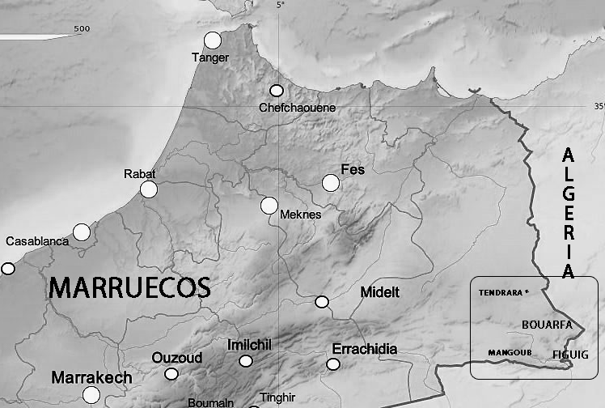
Fig. 1. Map of Bouarfa and the region in Morocco

Sheep farming is the main resource of the population, taking advantage of the few resources of an ecosystem typical of such dry areas, with poor steppe vegetation, scarce water and where the ravages of desertification are evident in the landscape.
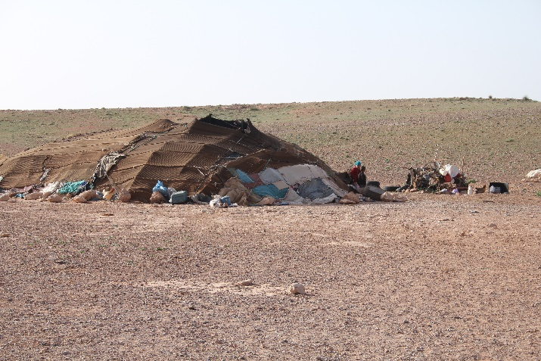
This use of the scarce resources of the territory has been made thanks to nomadism. Each family has carried out its livestock activity by moving according to the seasons and rainfall in order to make the most of the scarce pastures that these lands offer. Thus, the jaimas, traditional tents woven in wool, were moved with the whole family (fig. 2), moving up and down according to the season, to always return to the base camp, where a grain store has been built.
Fig.2. Jaima nomadic tent

However, in the last 20 years or so, a strong process of transformation has begun, a change of model that tends to sedentarization. This phenomenon can be seen in the fact that the tents, the key to this mobility, are fixed, along with other stable constructions mainly to house grain and for storage, near the tracks and roads that connect with the city. Also as part of this adaptation strategy, along with the new permanent constructions, agricultural crops have been intensified, reinforcing the sedentary character of this transformation. However, and although it may seem paradoxical, the mobile activity with livestock has not been renounced.
The cause of this abandonment of traditional nomadic practices is due to the increase in drought, the growing desertification and the greater fluctuations in the weather, which cause frequent rainfall crises that have a strong impact on the survival options of the inhabitants of these places. All the people interviewed speak clearly about desertification, the lack of rainfall and the problems that this entails, which has caused an important change in the way of life of the population, determined to change, to adapt to climate change, in order to continue living in a land they consider their own and with a way of life they are very proud of.
The process of sedentarization aims to obtain all the advantages of quick access to the city, thanks to vehicles such as motorcycles and donkey carts, but also to provide fodder and water, transported by these carts and by trucks and tractors, to make up for the rigors of droughts and allow the survival of livestock farming, the true lungs of the region's economy. Other elements that have accelerated this process are the growing demand for schooling for children, as well as access to the religious services of the mosque, together with new domestic technologies, which are increasingly in demand, especially by the new generations, and which require connection to the electricity grid. In this sense, we have been able to observe the existence of tents, symbol of nomadic mobility, connected to the electricity grid by cables, symbol of sedentarization.
Everywhere we have seen how the tribes, the real social axis of the local communities, have formed cooperatives to fight against desertification, planting species resistant to erosion and lack of rainfall, which fix the soil and promote pastures for the sheep to feed (fig. 3).
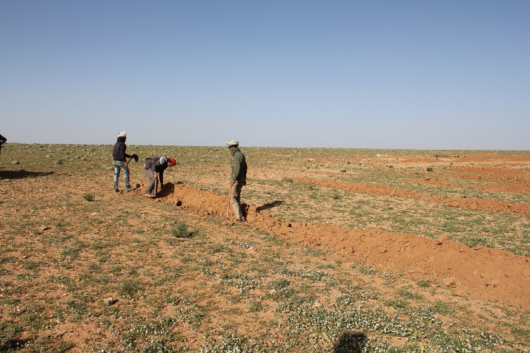
Fig.3. Fighting against desertification

For the visitor, this is a futile effort, as it involves planting in completely arid sites, tilling dry and rocky soil. However, one can perceive a strong commitment of the local populations, concretized in a strong investment in machinery and labor, to adapt as quickly as possible to the changing climatic conditions, underlining the commitment to remain on the land of their elders, for us completely barren, for generations to come.
In fact, the Bni Guil are adapting their habitation strategies to the new tools at their disposal, in order to face new challenges, among which desertification and drought stand out for their importance. This process that we have come to call "mobile sedentarization" takes advantage of the advantages of roads and dirt tracks, trucks and tractors, as Kreuer (2011, p. 59) has already pointed out for territories north of our study area, but it does not forget all the advantages that the mobile can provide.

CONCLUSIONS

Humanity is at the crossroads - facing important aggressions to the environment and nature, but also an unprecedented concern for the Environment. Environmental awareness is a fact, as Pope Francis rightly points out "The environment is a collective good, the patrimony of all humanity and the responsibility of all" (2015, p. 95). Indeed, the challenges we face are extraordinary; management of nature can no longer be left in the hands of biologists and environmentalists. The conservation of landscapes, the preservation of the environment, the struggle for the sustainability of the planet, are tasks that require involvement of all the actors including social science researchers (social workers, anthropologists and perhaps also sociologists). As we have argued, nature is not only plants and animals. Nature is inhabited, the landscape is constructed, protected natural spaces have been shaped by the hand of men and women.
Nature is also suffering from the terrible commodification of savage capitalism. Our most attractive landscapes also attract development of building such as hotel or luxury condominiums; privatization of the common good for the profit of a selected few.
We have been able to analyze this phenomenon in a recent work on the existence of conflicts between administrations and the inhabitants of protected spaces in the world (Vidal-González, 2016). The former, in an effort to "protect" those territories not yet urbanized or industrialized, focus on rural, mountain and inland areas, the most disadvantaged territories that are now attractive to city dwellers, eager and in need of new spaces of that lost and longed-for nature. The latter, inhabitants of these hitherto marginalized areas, see how the public authorities expropriate their land, imposing on them at least a series of protection obligations that we citizens do not apply to ourselves. Here, where you live, you can't build, you can't pollute, you can't grow.... you can't develop. I need you to continue without development so that I can enjoy someone else's territory after having already destroyed mine.
Compensation measures, positive discrimination, are imposed on the inhabitants of these spaces that are now so attractive. It is imposed because they are the ones who have preserved, thanks to their sustainable way of life, these environments. The rest of society must reward them, thanking them for having bequeathed us a natural heritage that we can all enjoy, but without infringing on their legitimate interests of development and well-being.
An intermediation is also necessary to defend and protect the rights of minorities, of the inhabitants of these peripheral environments, which are now of preferential interest to urban society. It is unreasonable, unethical and unsustainable that our yearning for environmental enjoyment, for the consumption of nature, should go against the legitimate rights and interests of its citizens.

The struggle to maintain the environmental balance is a struggle of all. Pollution in the North affects the most sensitive ecosystems, such as the polar ice caps, the Polynesian islands or the nomadic populations on the edge of the Sahara desert, such as the Bni Guild of Bouarfa in Morocco. Our unconsciousness, our wastefulness and our neglect are the cause of major imbalances affecting people, first in other places, but very soon in our own, if they have not already done so. As Pope Francis points out, "The inner peace of people has much to do with care for ecology and the common good, because, authentically lived, it is reflected in a balanced lifestyle coupled with a capacity for wonder that leads to the depth of life" (2015, p. 225).

REFERENCES

Díaz Pineda, F. (2003). “Paisaje y Territorio”. En Mediterráneo y Medio Ambiente. Colección Mediterráneo Económico, núm. 4. Caja Rural Intermediterránea. (Páginas 181-198).
Francisco. (2015). Laudatio Si. Librería Editrice Vaticana.
Gómez Mendoza, J. (2008) “La mirada del geógrafo sobre el paisaje: del conocimiento a la gestión”. En Maderuelo, J. (Dir.) (2008) Paisaje y territorio. (Páginas 11-56) Fundación Beulas. CDAN. Abada. Madrid.
Koch,E. 1998. “Ecofile”. Out There. (March). Page 71.
Kreuer,D. (2011). “Land Use Negotiation in Eastern Morocco”. Nomadic People. 15-1. 54-69.
Lebaudy,G. 2013. “The Controversy of Yosemite” (In French). “La Controverse de Yosemite”. L’Alpe. 62. 72-77.
Maderuelo, J. (2005). El paisaje. Génesis de un concepto. Abada. Madrid
Maderuelo, J. (2009) “La mirada del arquitecto”. En Martínez de Pisón, E. y Ortega Cantero, N. (Ed.) Los valores del paisaje. (Páginas 215-231) Universidad Autónoma de Madrid. Madrid. Fundación Duques de Soria. Soria.
Pfeffer,M.J. and Schelhas,J.W, Day,L,A. 2001. “Forest Conservation, Value Conflict, and Interest Formation in a Honduran National Park”. Rural Sociology. 66 (3). 382-402.
Vaccaro,I. and Beltrán,O. 2010. “Turning nature into collective heritage: the social framework of the process of patrimonialization of nature”, in Roigé,X. y Frigolé,J. (eds.). Constructing Cultural and Natural Heritage. Parks, Museums and Rural Heritage. 63-74. Girona. ICRPC Llibres, 4.

Vidal-González,P. 2014. “Stemming the tide. Opposition and Conflict in the Creation of Natural Protected Areas. A Case Study of the Natural Park of Puebla de San Miguel (Valencia), Spain”. Journal of Mediterranean Studies. 23-2. 225–237.
West, P., J. Igoe, and D. Brockington. 2006. Parks and peoples: the social impact of protected areas. Annual Review of Anthropology 35:251-277.

